GitHub – Repository Setup

T Godwin Abilash – 192321012

**GitHub Repository Setup**

**Question:**

Create a new GitHub repository for a personal project. Initialize the repository with a README.md file. Then, clone the repository to your local machine, make some changes to the README.md (e.g., add a project description), and push the changes back to GitHub.

**Tasks:**

Create a GitHub repository.

Clone the repository to your local machine.

Edit the README.md file.

Stage, commit, and push your changes to GitHub

**Procedure**

**1. Create a GitHub Repository**

1. Go to [GitHub](https://github.com/) and log in to your account.
2. Click the **"+" icon** at the top-right corner and select **"New repository"**.
3. Fill in the repository details:
   * **Repository name**: Enter a name for your repository (e.g., MyProject).
   * **Description** (optional): Add a description.
   * **Visibility**: Choose Public or Private.
   * Check the box for **"Initialize this repository with a README"**.
4. Click **"Create repository"**.

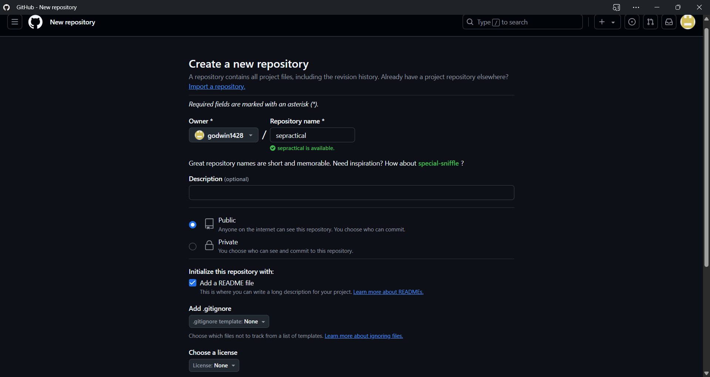

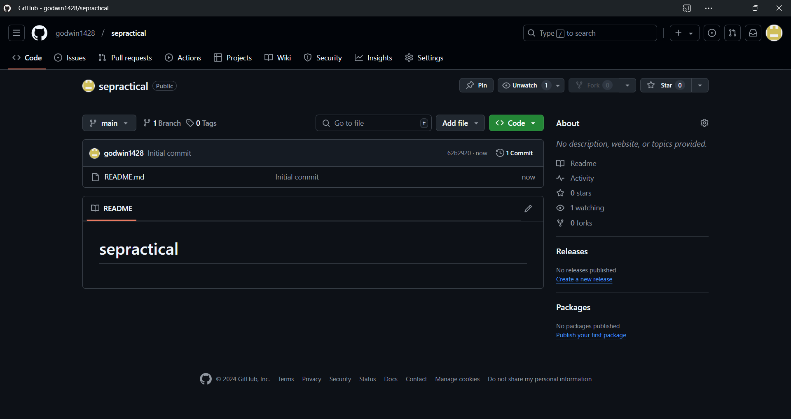

**2. Clone the Repository to Your Local Machine**

1. Copy the repository URL:
   * On the repository page, click the green **"Code"** button and copy the HTTPS URL (e.g., https://github.com/your-username/MyProject.git).
2. Open a terminal/command prompt on your local machine.
3. Navigate to the folder where you want to clone the repository:

cd /path/to/your/folder

1. Clone the repository:

git clone https://github.com/your-username/MyProject.git

1. Navigate into the cloned repository folder:

cd MyProject

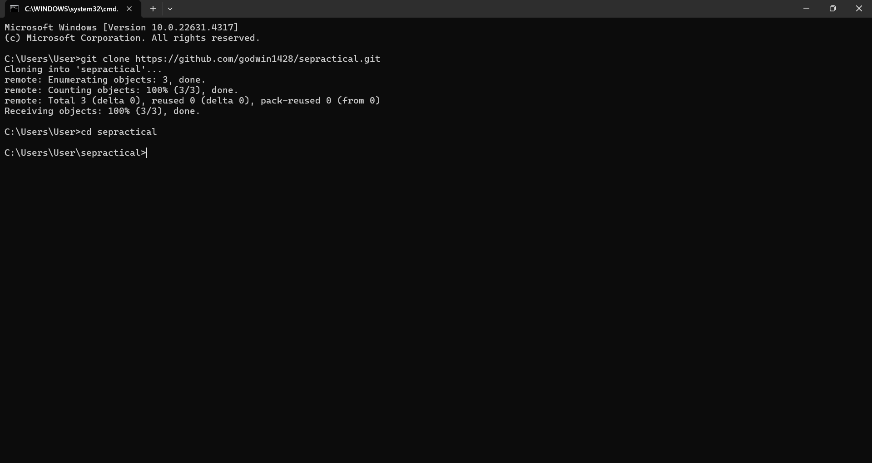

**3. Edit the README.md File**

1. Open the README.md file in a text editor of your choice.
2. Add a project description or make other changes, for example:

# MyProject

This is my personal project. It demonstrates how to use Git and GitHub effectively.

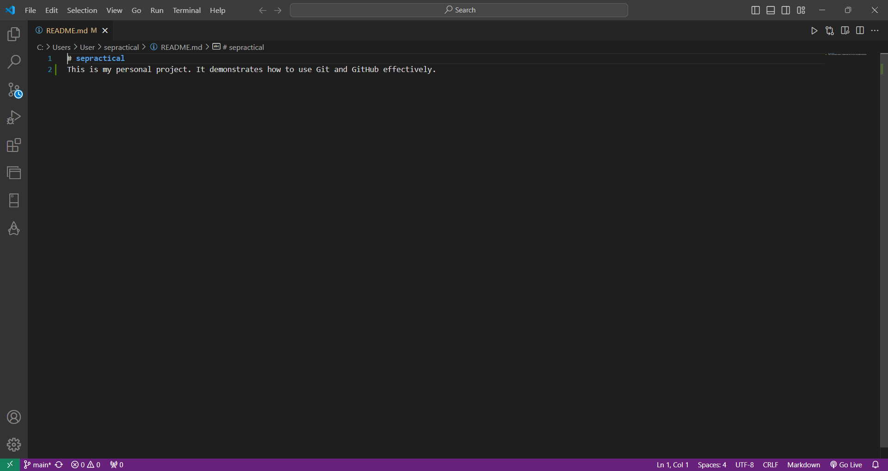

**4. Stage, Commit, and Push Changes**

1. Check the current status of the repository:

git status

1. Stage the changes:

git add README.md

1. Commit the changes with a message:

git commit -m "Added project description to README.md"

1. Push the changes to GitHub:

git push origin main

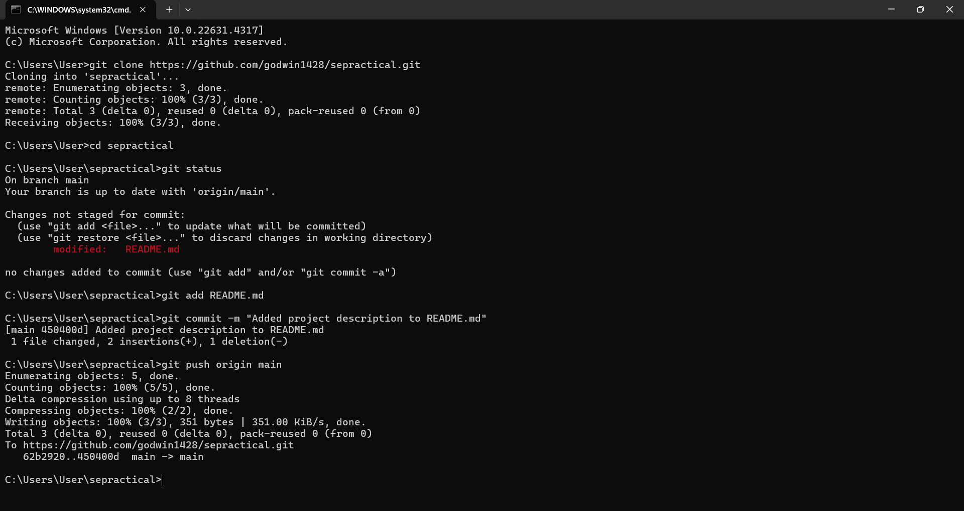

**5. Verify Changes on GitHub**

1. Go back to your repository on GitHub.
2. Refresh the page to see the updated README.md file with your changes.

